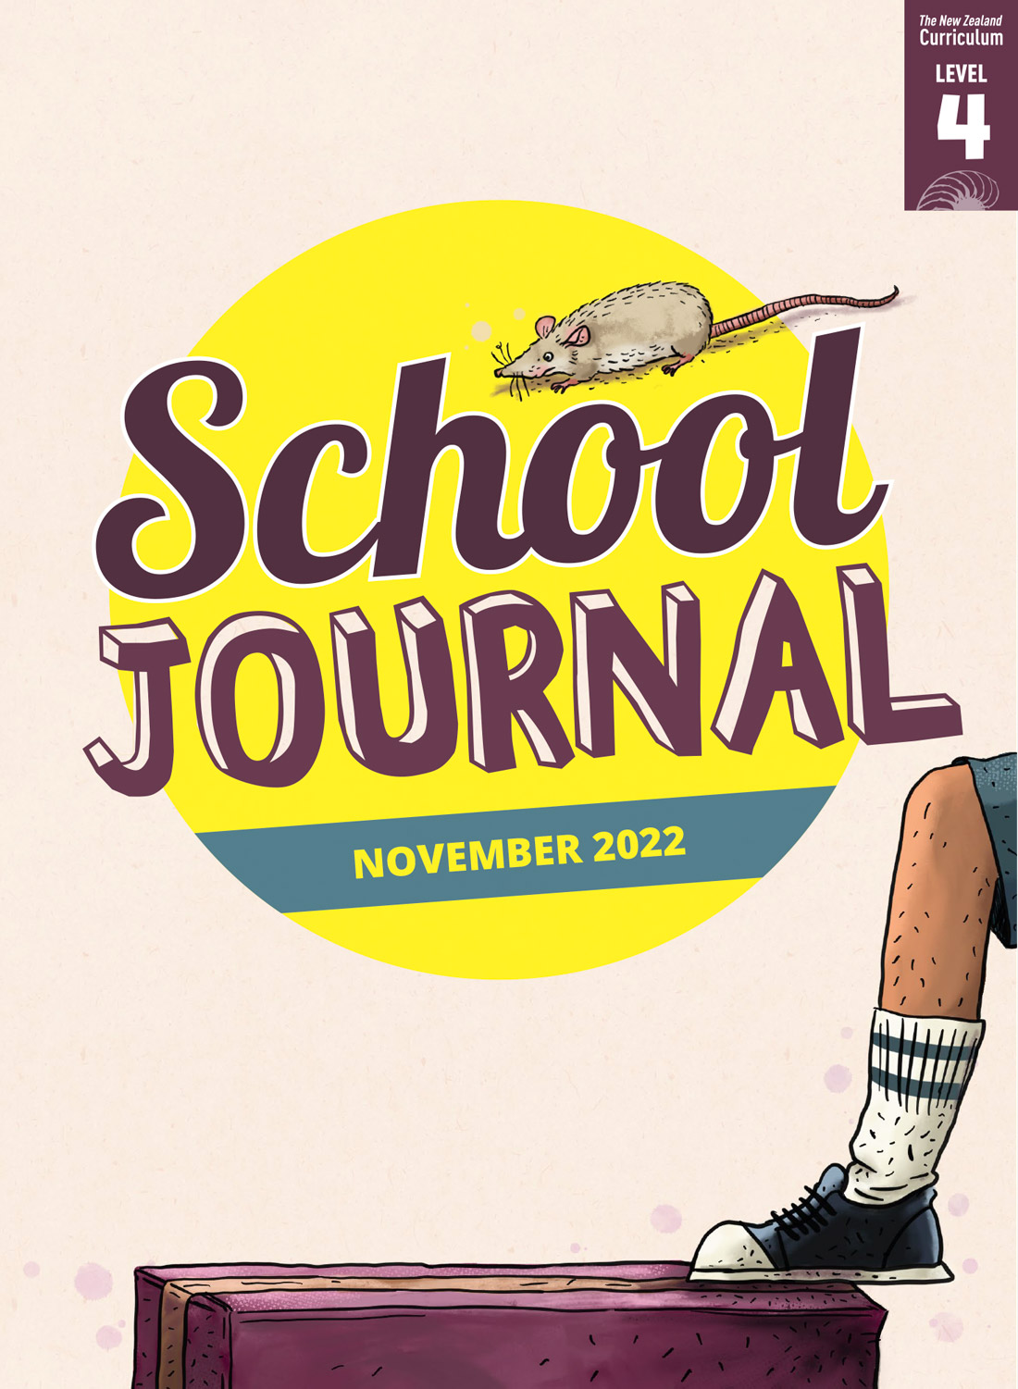

School Journal

Level 4, November 2022

**Reading level year 6**

# Kaitiakitanga

by Susan Paris

The [Learning Progression Frameworks](https://curriculumprogresstools.education.govt.nz/lpf-tool/) (LPFs) describe significant signposts in reading and writing as students develop and apply their literacy knowledge and skills with increasing expertise from school entry to the end of year 10.

## Overview

This article profiles four people who each express the qualities of a kaitiaki, protecting something they care deeply about for the sake of future generations. It includes a young climate activist intent on raising awareness to save future generations, an iwi historian who cares for the taonga and stories of his people, a Taranaki farmer who is incorporating sustainable practices on his dairy farm, and a Māori jeweller who follows her traditions when working with pounamu and looks after it as a taonga.

A PDF of the text is available at [www.schooljournal.tki.org.nz](http://www.schooljournal.tki.org.nz)

## Themes

“Kaitiakitanga” connects to the theme of this Journal. Other texts in this Journal (and the levels 2 and 3 journals for November 2022) also focus on this theme This article is scaffolded for extra support and is designed to build knowledge and introduce the important ideas and vocabulary connected with the theme of kaitiakitanga. On page 6 of this TSM, there is an overview of all the texts in this Journal, including a list of themes for each text. There is also a link to the audio for this text, which provides further support so ākonga can revisit the story as often as they need to.

The theme of kaitiakitanga refers to guardianship, care, protection of land and water, and the passing on of traditional knowledge.   
In te ao Māori, people are believed to have whakapapa connections within the natural world. All people share a responsibility to care for the environment. Among the texts that focus on kaitiakitanga, there are stories and articles that convey the message that if we care for nature, nature will care for us.

For further information about teaching and learning about sustainability, you could visit the [Education for Sustainability](https://nzcurriculum.tki.org.nz/Curriculum-resources/Education-for-sustainability/Teaching) website and the sustainability resource [Pūtātara](https://putatara.education.govt.nz/#/home). When discussing climate change, be aware that some ākonga may experience anxiety about the issue. The [Mental Health Education guidelines](https://hpe.tki.org.nz/guidelines-and-policies/mental-health-education/) provide comprehensive information to enable you to support the wellbeing of your ākonga.

**Other themes that can be explored in this text include:**

• Social responsibility • Climate change

## Texts related to the theme

**“Listening to the Land”** *Connected* L3 2018 | **“Rōngoa for the Land”** *School Journal* L4 Nov 2020 | **“Te Tapa Ingoa”** *Connected* L3 2018 | **“The Young Ecoleaders Award”** *School Journal* L3 Aug 2018 | **“Reducing Our Footprint”** *School Journal* L4 May 2021

## Strengthening reading behaviours (what to notice)

|  |  |
| --- | --- |
| Text structure and features | Requiring students to: |
| * An introduction that contextualises the four profiles and explains the meaning and origin of kaitiakitanga and its significance to Māori * Quotes that add more insight and information * Figurative language: “Our future was on the line; If you keep pushing at nature, you lose it” | * use their prior knowledge about kaitiakitanga and their understanding of the purpose of the headings to recognise that each section profiles someone who practises kaitiakitanga in a specific way * use their prior knowledge of profiles and interviews to understand the purpose of the quotes and to infer meaning using context, sentence structure, and word knowledge * use their prior knowledge of language features, as well as context, to understand that meaning is not always derived from individual words and that figurative language requires inference |
| * Abstract ideas from both te ao Māori and  te ao Pākehā | * infer meaning, make connections, and use concrete examples to form their own judgments about important issues. |

|  |  |
| --- | --- |
| Vocabulary | |
| Possibly challenging words  and phrases  Names  Te reo Māori | climate change, drastically, magnitude, crisis, activists, influence, ensure, bare minimum, disconnect, reality, palm-oil trees, biodiversity, pollution, nook and cranny, empowered, empathy, grazes, regenerating bush, species, covenant  Ranginui, Papatūānuku, Tāne-mahuta, Tangaroa, Rhiannon Mackie, Mitzi Jonelle Tan, Greta Thunberg, Nigel How, Wairoa, Te Kawiti, Ngāti Kurupakiaka, Evan Lobb, Inglewood, Taranaki, Hāwera, Middle East, Indonesian, Ana Krakosky, Te Ātiawa  kaitiaki, kaitiakitanga, te ao Māori, taonga tuku iho, whānau, hapū, iwi, hapori, kōrero, kaumātua, mana, taonga, mōrena, tīpuna, pekapeka, kōkopu, tuna, kārearea, tawa, miro, rewarewa, rimu, rātā, pounamu, tūpuna, whakataukī, wairua, tapu, tikanga, whakanoa, whakapapa |
| Helpful prior knowledge (pre-reading and introducing the text) | |
| * Some understanding of the concept of kaitiakitanga, which is about care and protection of cultural taonga and stewardship of the natural world and that it is an important concept in te ao Māori. (See [*Te Takanga o te Wā – Māori History Guidelines for Years 1–8*](https://maorihistory.tki.org.nz/en/programme-design/te-takanga-o-te-wa-maori-history-guidelines-year-1-8/).) * Some awareness of the threats to our natural world. * Some awareness of the ways that Māori maintain mātauranga Māori (Māori knowledge). * Some awareness of the ways cultures honour their ancestors. | |

## Possible reading and writing purposes

* Find out what it means to be a kaitiaki
* Understand and think critically about some different ways of being a kaitiaki
* Identify and describe how four people use their knowledge of kaitiakitanga to protect valuable resources
* Analyse and explain why the people profiled choose to be kaitiaki

See *Effective Literacy Practice in Years 5–8* for suggestions on using this text to teach comprehension ([Teaching comprehension](https://literacyonline.tki.org.nz/Literacy-Online/Planning-for-my-students-needs/Effective-Literacy-Practice-Years-5-8/Teaching-comprehension)) and for suggestions on using this text to teach ākonga to be effective readers ([Approaches to teaching reading](https://literacyonline.tki.org.nz/Literacy-Online/Planning-for-my-students-needs/Effective-Literacy-Practice-Years-5-8/Approaches-to-teaching-reading)).

## Possible curriculum contexts

## This text has links to level 4 of the New Zealand Curriculum in Social Sciences and Science.

## Understanding progress

The following aspects of progress are taken from the [Learning Progression Framework](https://curriculumprogresstools.education.govt.nz/lpf-tool/)s (LPFs) and relate to the specific learning tasks below. See the LPFs for more about how ākonga develop expertise and make progress in these aspects:

* Acquiring and using information and ideas in informational texts
* Making sense of text: using knowledge of text structure and features
* Making sense of text: vocabulary knowledge
* Creating texts to communicate current knowledge and understanding.

## Strengthening understanding through reading and writing

**After the first reading of “Kaitiakitanga”,** **select from the following suggestions and adapt them** according to the strengths, needs, and experiences of your ākonga. Most of these activities lend themselves to ākonga working in pairs or small groups.

* DISCUSS what ākonga know about the concept of kaitiakitanga. *What is kaitiakitanga? What is its root word?* (kaitiaki) *What does it mean to be a kaitiaki? What other words in te reo might connect to the word “kaitiakitanga” and help us understand this text*?
* ASK ākonga to compare how each person profiled is a kaitiaki. *What are the similarities and differences in the way they demonstrate kaitiakitanga? What connections can you find between their motivations, actions, and beliefs?*
* PROMPT ākonga to make connections between the actions of the kaitiaki described in the article and any examples of kaitiakitanga practised by people they know. These may include actions ākonga have taken themselves. *Do you know anyone who is a kaitiaki? What makes them a kaitiaki? What words in your first language have a similar meaning to kaitiaki?* You could also encourageākonga to think about people from their own culture who are kaitiaki. For example, family members in some Pacific cultures act as kaitiaki by speaking on behalf of the family and passing on ancestral knowledge. In Tokelau, children often take on the role of “tokotoko” by caring for their grandparents*.*
* REVISIT the “Rangi and Papa” text box on page 2. Check ākonga have inferred that the phrase “into being” means that the children of Rangi and Papaare parents of all things, so there are whakapapa connections between humans and the natural world. *How does this deep sense of connection influence how Ana Krakosky works with pounamu? How does this compare with the other people featured in the article? In your culture, do you have a similar connection between people and the natural world? Is this reflected in the way you honour your ancestors or the way you care for the environment?*
* REVIEW the text with ākonga to identify and explore other concepts that connect to kaitiakitanga (for example, threats such as pollution and climate change and actions such as raising awareness and protecting biodiversity). Demonstrate how to create a [concept map](https://esolonline.tki.org.nz/ESOL-Online/Planning-for-my-students-needs/Resources-for-planning/ESOL-teaching-strategies/Thinking-and-metacognition/Concept-map) with “kaitiakitanga” at the centre and the other concepts grouped and connected with arrows to indicate how they relate to each other. Encourage ākonga to explore different kind of connections. Model how to use the concept map to write and say sentences that explain important ideas, using connecting words and phrases, such as “for example”, “because”, “but”, and “in addition”.
* FOSTER CRITICAL LITERACY by focusing on subheadings such as “Our Future on the Line”. *What is the writer’s purpose in adding these subheadings? Why did she choose them? How helpful were the subheadings in leading you into the information about the kaitiaki? What are some alternative subheadings?*
* DISCUSS with ākonga what Rhiannon means when she says, “Our future was on the line”. Prompt them to use their knowledge of figurative language to work out that “on the line” means the world and everything in it is threatened and the future of the next generation is uncertain. Prompt ākonga to find other examples of figurative language and explore what these mean. Discuss why so much figurative language has been used in this non-fiction text. Draw out that some of the people profiled are activists and the writer is trying to persuade us of the importance of kaitiakitanga. Emphasise that figurative language is a feature of persuasive writing.
* DISCUSS with ākonga the statement on page 2 that “In recent years, interest in kaitiakitanga has grown as people work to protect the things that are important to them or are under threat”. *What evidence can you find in the text to support this? Do you agree?*
* HAVE ākonga use the text as a model to write profiles of local people who engage in kaitiakitanga or of the young climate activists who inspired Rhiannon Mackie. Alternatively, they can write and illustrate profiles of Ranginui, Papatūānuku, or one of their children, focusing on the role of these atua (spiritual beings) as kaitiaki of the natural world.
* ASK ākonga to use the “Reflecting on the text” template on page 5 of this TSM to organise information from the text. They can compare how each person in the article expresses kaitiakitanga before reflecting on whether kaitiakitanga is important to them and how they might practise it.

## If ākonga need extra support

* Have ākonga scan the text before reading to predict its purpose and explore how the information is organised. Then ask them to read page 2 to check their predictions. Clarify that each section profiles a different person whose life and work demonstrates kaitiakitanga.
* Identify any words you may need to pre-teach, keeping in mind that some ākonga may prefer to read the article independently before going back to clarify meanings. If necessary, model the pronunciation of words in te reo Māori. The audio version provides support.
* Have ākonga create vocabulary posters where they choose a word from the text that they want to explore and then present as a poster to the class. Explain they will describe, illustrate, and define their word and include some synonyms, antonyms, the origin of the word, number of syllables, and some collocations. Prompt ākonga to check whether others will understand their definition and if not, to rephrase it so the meaning is clear. Is their illustration a true representation of the word and will ākonga understand it? Would using multiple illustrations help them to better visualise and learn this word?When presenting their word to the class, encourage ākonga to guess the meaning or pronunciation of the word and to monitor their understanding of it. Encourage them to ask questions to strengthen their understanding.
* If ākonga are having difficulty working out the meaning of the figurative language, provide them with a specific explanation, then ask them to illustrate the meaning. Check their understanding.
* Encourage ākonga to ask questions about the text and to revisit these frequently to check what they have found out and to ask any further questions.
* Discuss the relationship between the terms “kaitiaki” (guardian) and “kaitiakitanga” (guardianship). Have ākonga compare these terms on a double bubble map. *How do you know these similarities and differences? What have you learnt by creating this map? Why are these similarities and differences so important?*
* Focus on the words “taonga tuku iho” – the treasures handed down from our ancestors. Ask ākonga what they consider as taonga. Use their examples to clarify that as well as the treasures of the natural world that have been passed down, they are also the cultural treasures of language, knowledge, and history. *What do the subheadings suggest about the kind of taonga each kaitiaki is protecting?* Record their predictions for ākonga to check as they read.
* Share-read with ākonga where necessary and provide the audio for them to revisit the story as often as they need to. Some ākonga may benefit from listening to the audio before reading and discussing the text with others.
* Prompt ākonga to ask questions and find answers to them as they read. This is an opportunity to model the fact that we will not always find answers to our questions within a text and that sometimes we need to look further. *I’m not sure who Mitzi Jonelle Tan is. Let’s find out about her and what Rhiannon might have learnt from her*.

## Reflecting on the text: **“Kaitiakitanga”**

|  |  |  |  |  |
| --- | --- | --- | --- | --- |
|  | **Rhiannon Mackie** | **Nigel How** | **Evan Lobb** | **Ana Krakosky** |
| **Taonga tuku iho**: What this person protects |  |  |  |  |
| **Action**: How this person practises kaitiakitanga |  |  |  |  |
| **Motivation**: What makes this person want to be a kaitiaki |  |  |  |  |
| **Summary**: How would you explain the concept of kaitiakitanga to another person? |  | | | |
| **Reflection**: How relevant is the idea of kaitiakitanga to people in Aotearoa NZ today? Should we all act as kaitiaki? What taonga would you like to protect? How might you do this? |  | | | |

## School Journal | Level 4 | November 2022

Exploring a theme: The texts marked with a  share the theme of kaitiakitanga.

|  |  |  |  |  |
| --- | --- | --- | --- | --- |
|  |  | **Reading level** | **Themes** | **Curriculum  links** |
|  | **Kaitiakitanga** ARTICLE  This article profiles four people who express the qualities of a kaitiaki: a young climate activist, an iwi historian who cares for the taonga and stories of his people, a Taranaki farmer who is incorporating sustainable practices, and a Māori jeweller who works with pounamu. | Year 6 | Kaitiakitanga  Social responsibility  Climate change | Social sciences  Science |
|  | Going in Nature STORY  In this humorous story, the narrator and her dad try to find a solution to the “mess” freedom campers leave on the nearby reserve. | Year 7 | Kaitiakitanga  Humour  Tolerance  Persistence | English  Health and PE |
|  | After the First Rain STORY  In this sequel to the speculative story “Bucket Man” (SJ L4 June 2022), the narrator’s gran has died and day-to-day survival is still a struggle. The bucket man needs a new partner to continue the search for a solution to the climate catastrophe and the narrator has to decide whether he will keep his grandmother’s knowledge alive. | Year 8 | Climate change  Knowledge/learning  Kaitiakitanga | English  Health and PE |
|  | The Box SCREENPLAY  When a group of students is left in charge of a box, they all have different ideas about what’s inside it – and who is the kaitiaki? | Year 7 | Group dynamics  Humour  Kaitiakitanga | The arts: drama  English |
|  | Humphrey Hanley: Life on the Upside ARTICLE  Imagine having a disease where you can’t dress yourself or pack your own school bag. Imagine losing skin every time you bump into something – or start each day having your limbs wrapped in bandages. | Year 7 | Living with a disability  Persistence/adaptation  Wellbeing | Health and PE |
|  | How Vaccines Work ARTICLE  How do vaccines work? What are infectious diseases? What is herd immunity? This article presents the facts and science about vaccines and our immune systems and how vaccinations protect communities. | Year 8 | Kaitiakitanga  Infectious disease  Viruses | Science  Health and PE |
|  | Leftovers for Breakfast POEM  How did we get here? Where do we come from? How long is a piece of string? | Year 8 | The universe | English  Science |
|  | Tāne-mahuta Student Writing  A night-time walk and the sighting of a kiwi soothe the narrator’s troubles and worries. | N/A | Resilience | English  Health and PE |